**EE 152 Final Project Proposal: Laptop Based Radar**

Minwo Wang and Albert Wandui

1. INTRODUCTION

Our goal is to design and implement a laptop based Doppler radar system that can be used to measure the velocity of passing objects to within a 70m radius. Doppler radar involves bouncing microwave signals of off a desired target and measuring the induced frequency change due to the motion of the object. Doppler radar finds numerous applications in sounding satellites, aviation, meteorology, radar guns and much more.

The non-relativistic Doppler effect (where the velocity of the object $v≪c$, the speed of light) can be expressed as

$${∆f= f}_{RX}-f_{TX}=f_{Tx}∙\frac{2v}{c}$$

where $f_{RX}$, is the frequency of the received signal and $f_{TX}$ is the transmitted signal. For typical velocities about 20-45 mph, the Doppler shift ranges from 350-800 Hz. The Doppler frequencies are in the low audio range and as a result, we can use the computer sound card to sample and digitize our signal for the velocity measurements.

In this project, in place of more expensive high gain horn antennas that would be typical of scientific or commercial radar instruments, we will design our very own cantenna which promises moderate gain at a fraction of the cost. The cantenna couples power from a quarter wave coax line dipole antenna into a cylindrical waveguide with a diameter $d$. The waveguide acts to greatly improve the gain of the antenna. For a free space wavelength equal to $λ$, then the maximum gain for a cantenna is $G= {\left(π\frac{d}{λ}\right)}^{2}$. Each mode of the waveguide has a cutoff frequency below which no waves can propagate in the waveguide. The cutoff frequency is determined by the mode number $p_{n,m}$ of the waveguide. We chose to use the TE11 mode because it is the fundamental mode of the cylindrical waveguide and hence easy to excite. The cutoff frequency is given by the equation

$$f_{c}=c\left(\frac{p_{n,m}}{π d}\right)$$

Figure 1, summarizes these two equations for the cutoff frequency and the gain as a function of the cantenna diameter. In our design, we chose a diameter of 2.7 inches which gives a 12 dBi gain. While the gain is low, the cutoff frequency is conveniently 2.7 GHz, just above the 2.4 GHz ISM band in which wifi, Bluetooth and other short range low power transmission systems are allocated. Such signals would cause high levels of interference rapidly degrading our measured signals.

Given the transmitted power $P_{TX}$, we can calculate the power in the receiver using the antenna equations. The ability of the target to be detectable by the radar system is encoded in the radar cross section of the target $σ$. The radar cross section is the ratio between the scattered power and the incident power flux. For a target at a distance R from the antenna with a gain G in the direction of the target, the power flux is given by

$$\frac{P_{TX} G }{4 π R^{2}}$$

The target (we assume) scatters the radiation isotropically in all directions and thus acts as an antenna of its own. The receiver sees the radiation from this antenna and we can compute the power at the receiver using the Friis transmission equation as

$$P_{RX}= \left(\frac{P_{TX}G}{4 π R^{2}} σ\right)∙\left(G\frac{λ^{2}}{4 πR^{2}}\right)∙F^{4}$$

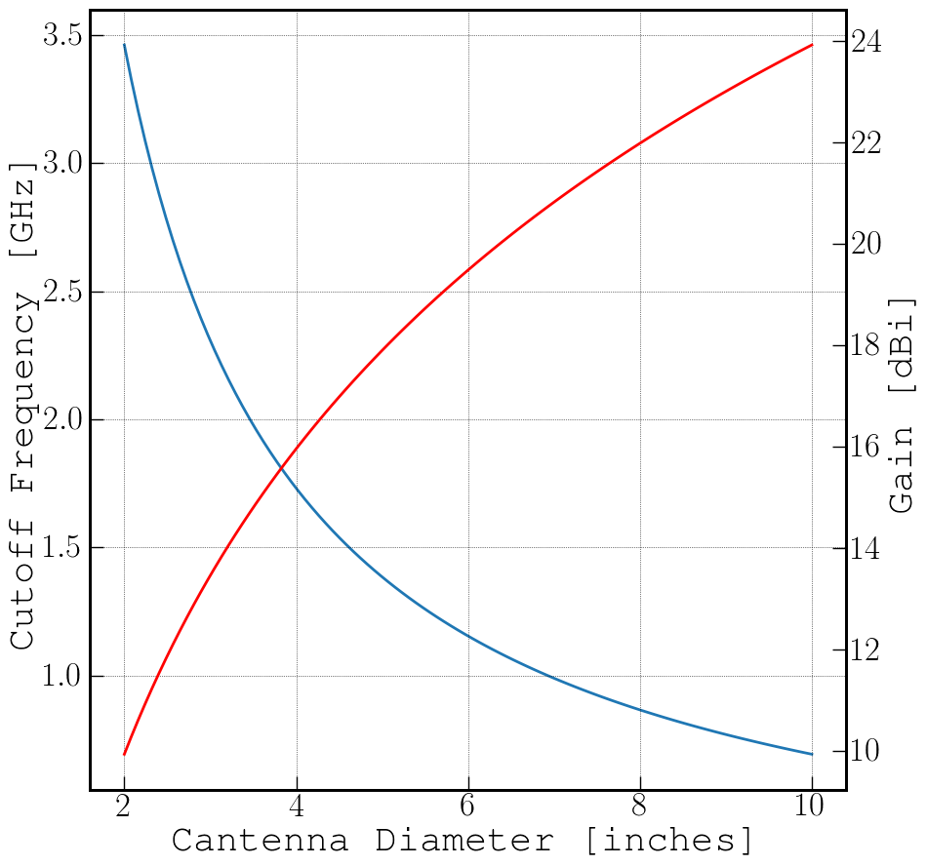The first term in brackets, is the power radiated by the target back towards the receiver. The second term is the effective area of the receiving antenna while the factor F is the pattern propagation factor. F encapsulates higher order effects such as diffraction, further scattering and multipath transmission between the source and the target. The power measured at the receiver has a strong $1/R^{4}$ dependence and hence is very sensitive to changes in the transmitted power, gain or pattern propagation.

Fig 1.1 Cantenna Cutoff frequency and Gain vs Diameter plot

1. SYSTEM DESIGN

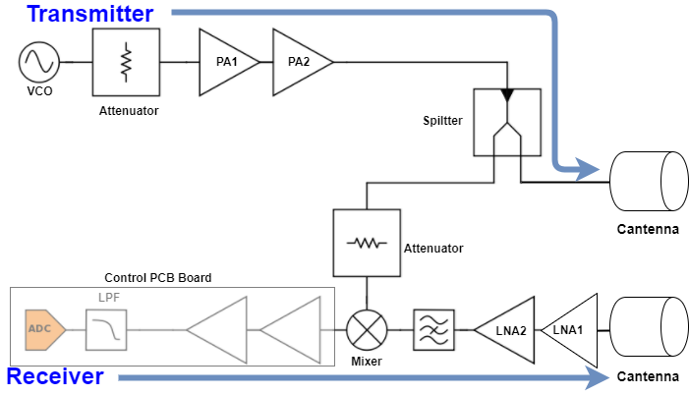

Fig 2.1 System level block diagram

* 1. TRANSMITTER DESIGN

Transmitter Cantenna dimension is 2.6 inches, cutoff frequency is 2.7 GHz, and the gain is around 12 dB. From the Lab6 measurement, we get 5.4 dB antenna gain, which has maximum gain of 15 dB. Hence, to be safe, we assume 4~5 dB antenna gain will be achieved.

We will use ZX95-5776-S+ as our voltage control oscillator, which has 1.5dBm source power from the datasheet. PA1 is the power amplifier we have from the Lab5, which has 11 dB gain, and its 1-dB compression point happens when output power is 7 dBm. So the attenuator’s value is calculated by

$$L=7dBm-1.5 dBm-11=5.5 dB$$

PA2 is the ZX60-83LN-S+. Its gain is around 21.5 dB between 0.5 and 8 GHz, so maximum 28.5 dBm power goes to the splitter. For unbalanced power splitter, we will design it targeting 1 dB loss to the Transmitter Cantenna and 5 dB loss to the receiver’s Mixer. Also there is around 1~2 dB loss coming from the cable connected to the Cantenna.

From above calculation, transmitted power is $P_{tx}=1.5-5.5+7+21.5-3=25.5 dBm$.

The radar detection distance is calculated by

$$P_{RX}=P_{TX}∙G^{2}∙\frac{λ^{2}∙F^{4}∙σ}{{\left(4π\right)}^{3}R^{4}}$$

where $F$ is pattern propagation factor (F equals 1), $σ$ is radar cross section and $R$ is the detection distance. Assuming oscillation frequency is $5.9$ GHz, we are able to achieve $46$ m radar detection distance.

* 1. TRANSMITTER DESIGN

As mentioned before, 28.5 dBm power goes to the splitter so that 27.5 dBm goes to the transmitter Cantenna cable and 23.5 dBm power goes to the Mixer’s attenuator. At this moment, assuming mixer distorts at 3 dBm, we need 20 dB attenuator. For LNA, we will design our own LNA operating at 5.9 GHz, which has at most 150K equivalent noise temperature. We can get rough approximation of LNA from Lab3, though it operates at 4 GHz. Assuming its gain is roughly 11 dB. Also, we will implement Image Reject Filter, which will contribute to 2 dB loss. Assuming $P_{rx}=-81 dBm$, Mixer’s conversion loss is $-10$ dBm and $-69 dBm$ is required to go into control PCB board, one more amplifier should be implemented before the image rejection filter. Its gain is calculated as

$$G=-69-\left(-81\right)-10+11-2=11 dB.$$

Also its noise will be added by Friis noise equation:

$$T_{eq}=T_{1}+\frac{T_{2}}{G_{1}}$$

where $T_{1},T_{2}$ are noise temperature of $LNA_{1}$ and $LNA_{2}$ and $G_{1}$ is the LNA1’s gain.

|  |  |  |  |
| --- | --- | --- | --- |
| Components | Implementation | Power or Gain | Loss or Noise |
| VCO | ZX95-5776-S+ | 1.5 dBm |  |
| PA1 Attenuator | K2-BW3+ |  | 5 dB |
| PA1 | Lab5 Project | 11 dB |  |
| PA2 | ZX60-83LN-S+ | 21.5 dB |  |
| Splitter | Designed Part |  | 1 dB and 5 dB |
| Cantenna | Designed Part | 5 dB(11 dB for Max) |  |
| Mixer Attenuator | K2-BW3+ |  | 20 dB |
| LNA1 | Designed Part | 10 ~ 11 dB | 150 K |
| LNA2 | Designed Part | 10 ~ 11 dB | 150 K |
| Image Reject Filter | Designed Part |  | 2 dB |
| Mixer | Designed Part |  | 8 dB |

Table 1. System Specification.

|  |  |  |
| --- | --- | --- |
| **Designed Components** | **Passive** | **Active** |
| Unbalanced Wilkinson | Mixer |
| Image Reject Filter | Power Amplifier |
| Antenna | Low Noise Amplifer |
| **Purchasing** |  |  |
| Attenuator | Voltage Control Oscillator |
|  | Power Amplifier 2 |

Table 2. Component we are designing vs purchasing

1. BILL OF MATERIALS

While the majority of components we need are available from the lab inventory as well as our own designs from previous labs, there are a number of parts that still require purchasing.

|  |  |  |  |  |  |  |  |
| --- | --- | --- | --- | --- | --- | --- | --- |
| **Cantenna** | | | | | | | |
| **Callout** | **Qty/Kit** | **Part #** | **Description** | **Supplier** | **Supplier Part #** | **Cost Each** | **Subtotal** |
| Can | 2 | TBD | Cans for cantenna | Trader Joe’s/Pavilions |  | $5.00 | $10.00 |
| 12” SMA M-M cables | 3 | 086-12SM+ | SMA-SMA HFlex 12” Cable | Mini-circuits | 086-12SM+ | $12.95 | $38.85 |
| **Radar RF** | | | | | | | |
| OSC1 | 1 | ZX95-5776-S | 5726-5826 VCO +1.5 dBm out | Mini-circuits | ZX95-5776-S | $54.95 | $54.95 |
| PA | 1 | ZX60-83LN+ | LNA 21.5 dB gain, IP3 34 dBm | Mini-circuits | ZX60-83LN+ | $154.95 | $154.95 |
| Modulator | 1 | |  | | --- | | XR-2206 | | Function Generator Chip | Jameco | |  | | --- | | 34972 | | $7.95 | $7.95 |
| AA Batteries | |  | | --- | | 8 | | PC1500 | AA Battery  1.5 V | Mouser | 613-MX1500 | $1.52 | $12.16 |
|  |  |  |  |  |  |  | $278.86 |

1. SUMMARY

As described above, we want our radar system to cover more than 46-meter distance range. The block diagram with each component’s specification is shown in Section 2. Among core components, we plan to purchase VCO and Power Amplifier. The power amplifier’s performance directly affect the distance radar can cover. The expensive PA listed in Section 3 is the one we found in the lab, and its price is gotten from the Mini-circuits website. Because of its expensive price, the total cost is more than $150. We have to discuss further about it.